Login and navigation
Login:
To begin editing your sites, go to the user login screen at the following URLs
Temporary link = http://solanaonline.com/user
You should see a screen as below, enter your username and password
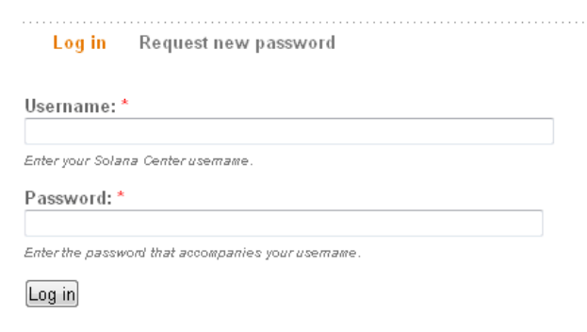
Navigation:
Once logged in, you will see an admin menu at the top of the page, and other editing links and tabs on most pages.
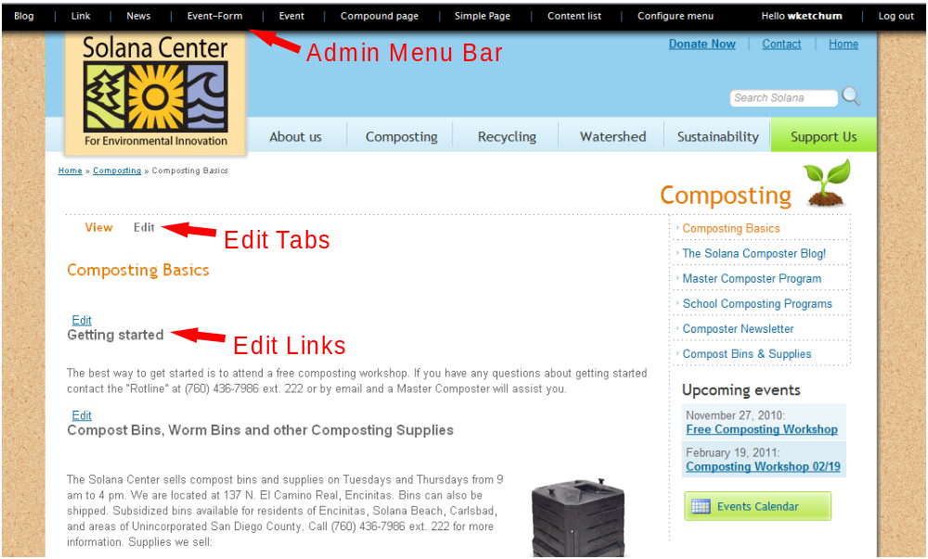

We’ll look at using these admin features later, but for most site work it is easier to use the top drop-down menu, or the right column section menu to navigate to the page you want to edit or change. There you can use the edit links and tabs to add and edit most content.
Page layout
Page Types:
It is important to note that there are two types of site pages.
Compound pages contain multiple articles, which are like blog posts and have individual titles and content. Here each article has been outlined in red.
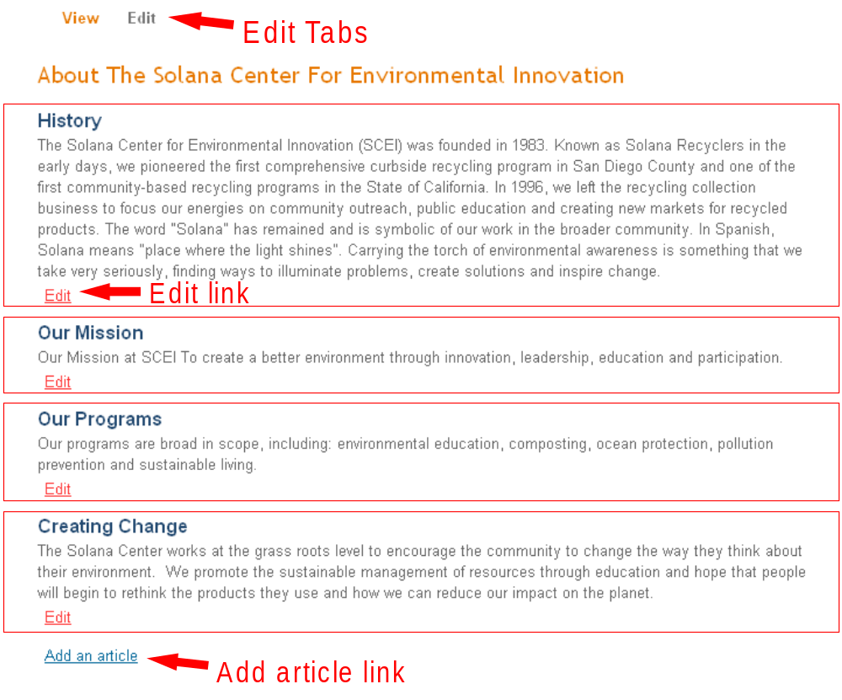
On compound pages, the edit tabs will only allow you to change the page title, which in the pic above is About the Solana Center… . To edit the other content you must use the (red) Edit links below each article title. Click on the (blue) add an article link at the bottom of the compound page to add another article to a compound page.
Simple pages contain only a single text block, and you will see only the top edit tabs on the page.
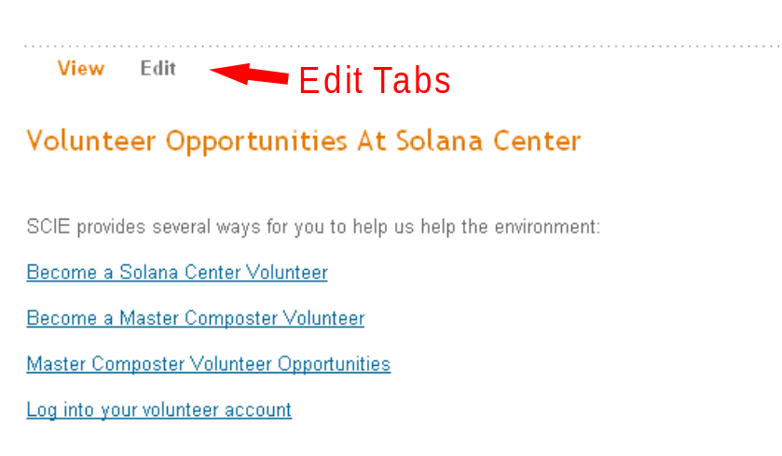
Toolbar and content types
Toolbar:
When logged in as a site editor, you will see a black admin toolbar at the top of your browser window. the toolbar provides convenient links for content creation and management.
The first six links are for content creation of the named content types.
Content type links:
Blog = blog post, and adds another blog post to the blog. the post will automatically be added as the first post, and will bump all other posts down a notch.
Link = link list item. These are the items that show up on the site front page in the Important Links section. The order of these items is determined by the value you insert into the rank field on the editing screen for the new item.
News = news item. This is a special item only appears on the site front page in the In the News section. When editing the news page, remember that the only part of the page that shows up on the front page is the body. Maximum picture size is about 200 x 267 pixels.
Event-form = a dedicated signup form for a new event. If you are adding an event or workshop that requires signup, you need to create the signup sheet first. A detailed recipe for creating workshops with signup forms can be found later in this document.
Event = an event or workshop you want to list on the site. These items will show up in the Upcoming Events section of the front page, as well as in the calendar and events listings in the different site sections. Which section(s) the events are listed in is determined by a selection list, and the rank is determined by the rank value and date.
Compound page = a page that contains multiple articles. Each article is like a blog post and should contain information about a particular item of interest to the site visitors. The new compound page will automatically contain an add link for adding your new articles. Articles are convenient because they are already styled for a consistent look, and will also contain edit links.
Simple page = simple page type that contains only one text area. Generally used for importing pages from other sites or other single use activities.
Content list link:
The content list is a sortable table of all the pages, articles, posts, forms and other content contained in the site. Using the content list is outlined later in this document .
Configure menu link:
The configure menu link is used to configure the master menu that controls the section menus that appear at the top of the right hand column in each individual section. The drop down menu at the top of the site is controlled by another menu, and because it is individually styled, should not be changed. Using the configure menu screen is outlined later in this document .
Events – no registration
Events without registration:
For simple events, just fill out the event form. You should include enough information that your user can decide if they are interested in this event. For further information, you can upload pdf pages that describe your event and link them to the event listing using the link tool. (as outlined in the using the editor section of this document)
Event titles and dates are listed in the section event lists and the site calendar. Which section(s) the events are listed in is determined by the event category field. Selecting all is a quick way to include the event in all sectional listings.
All events show up on the calendar, irrespective of the section selection setting.
The listing order is determined by the rank value and then date. Use the rank field to move special events up to the top of the list, otherwise leave this field blank and the events will show up in order of their dates.
After the date of the event has passed, the event listing will be removed from all event lists. The event page and calendar listing will remain in the system.
Events – with registration
For events or workshops where registration is required, the first step is to create a registration form for your new workshop.
Create Event Form: Click on the Event-Form link in the black admin bar.
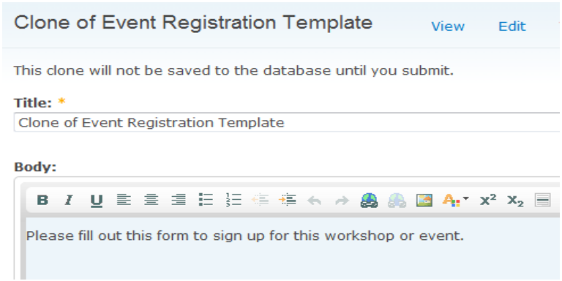 | In the new form, replace Clone of event registration template with text that includes the name and date of the event. This way you can identify which event your user are registering for.  The body text tells your users what to do with the form. You can change this text as you like. When finished, click save.
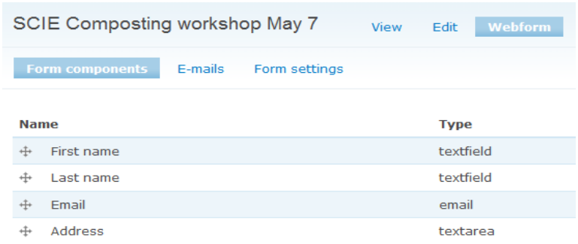 | After saving, you are taken to the webform editing screen. Usually you don’t need to make any changes here.  You can check the email that the registration notifications will be sent to by clicking on E-mails.
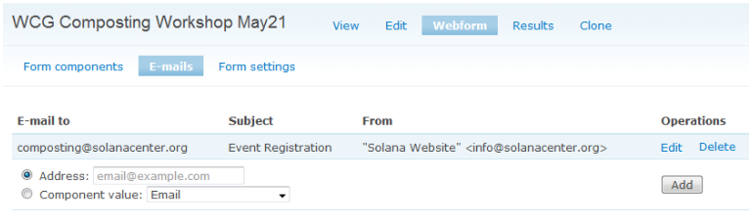 | The first line is the destination email, here composting@sola-nacenter.org. If required, click on the edit button to the right to change.
Now go to the event shortcut in your admin bar to add your new event.
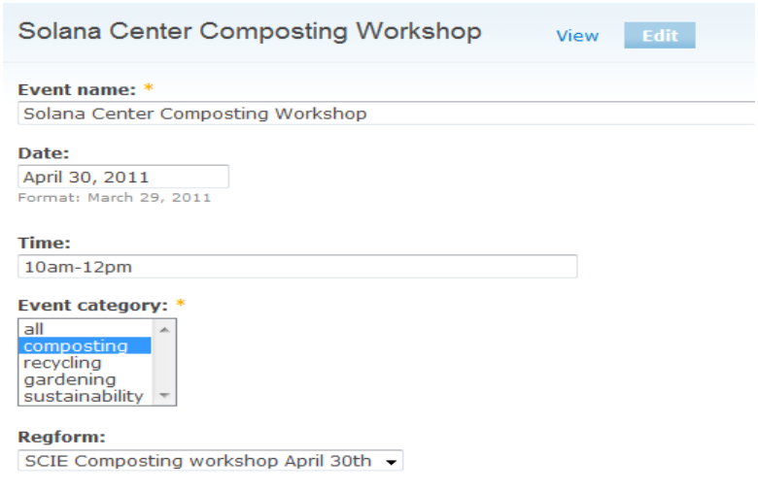 | Create your new event as outlined in the previous section.  In the regform field, be sure to select the name of the signup form you’ve just created.  After saving, your workshop should now have a link showing at the bottom that takes your user to the new signup form you created.
Wysiwyg Editor – Using the editor
Admin Toolbar:
When logged in as a site editor, you will see a black admin toolbar at the top of your browser window. the toolbar provides convenient links for content creation and management.
The first seven links are for content creation of the named content types.
Editor Toolbar
The text editor function is similar to most word processing programs and includes a button bar at the top of the text entry area. It will appear in most multi-line text areas when editing.
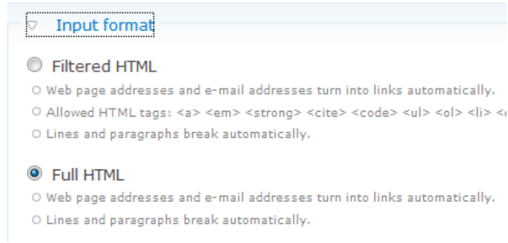 | If the bar does not show up. Check just below the text entry area for the Input format tab and click on it to expand the selections.  Make sure that the Full HTML format is selected, and the editor will turn on.
If you hover your cursor over any button on the button bar, a tool tips will appear to tell you it’s function. Most of the button functions are pretty straight forward except the link and image functions, which we will examine next.
Wysiwyg Editor – Inline image insertion and editing
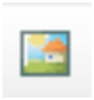 | The enlarged button shown here is for image insertion and editing. To insert an image, place your cursor where you want the image to appear and click this button. To edit an image, double click the image or select it and click the button.
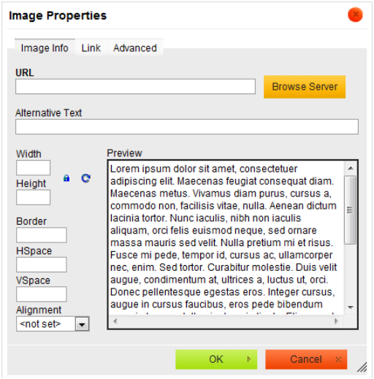 |  | After this dialog box opens, click on the Browse Server button seen towards the upper right.
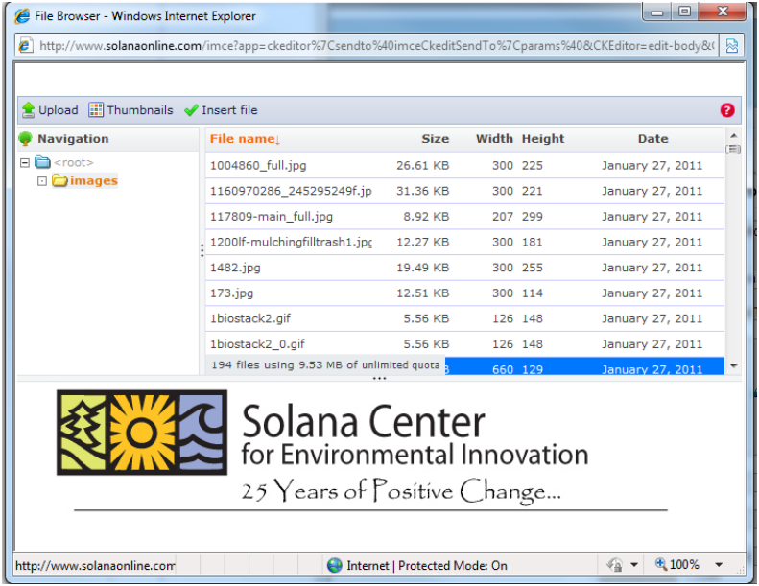 |  |  | Now this dialog box will open, which shows a list of the images already on the system.  If the image you need is in the list. Select it by double clicking. Single clicking on a file name will open a preview pane in the lower part of the box so that you can see the image.  If you need to upload a new image, click the green upload arrow found in the upper left corner of the screen.
Wysiwyg Editor – Inline image insertion and editing
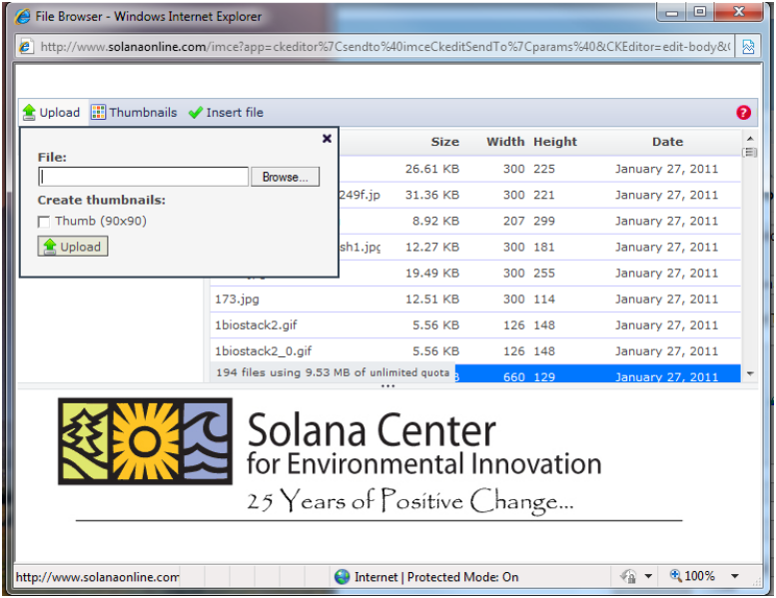 |  | An additional popup will open, now click the Browse button to browse your local computer and upload the image you want.  After uploading, the new file, it’s name will appear in the file list, and you can select it by double clicking, or preview it by single clicking on it’s file name.
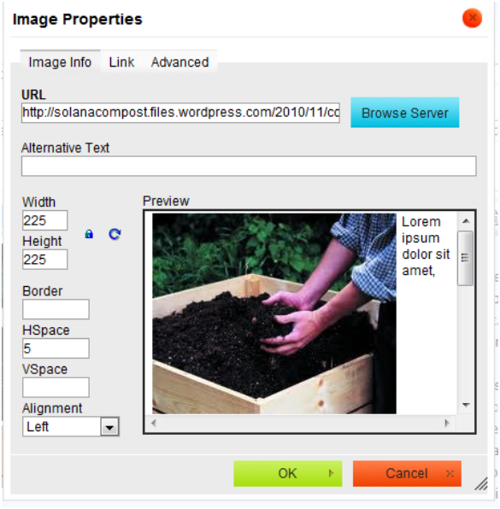 | After double clicking a image file name, you will be returned to this original dialog box, now with an image in it!  At the bottom of the box you can select left or right alignment of the picture relative to the text which will wrap around it as shown by the dummy text in the preview pane.  Above that you can add some horizontal and vertical spacing as required to separate the image from the text. (I’ve added 5 px horizontal here)  You can also experiment with borders and other advanced settings if you know html style code.  Click OK to return to your page.
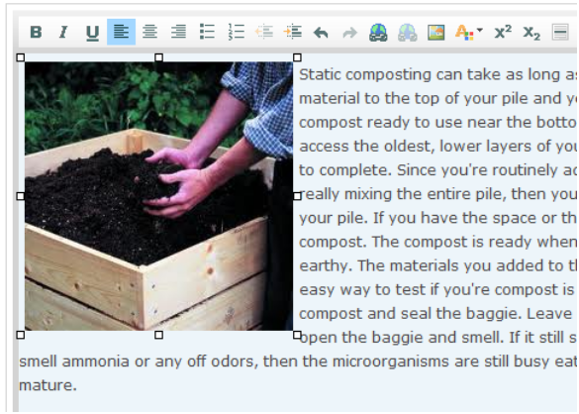 | Finally you can see your inserted image and your text in the text editor pane of the new page screen!  You often need to experiment with various settings to get the look you want. Web page code is not as friendly as word processing code, so just keep trying!
Wysiwyg Editor – Link insertion and editing
Determine the target first:
The key to working with links is that you must identify the target first.
For an on-site page, go to the page and copy the part of the URL after the name of the site. For the page http://solanaonline.com/school-recycling, the part you need is school-recycling.
For an off site page, you will need the whole URL after the http:// part.
For an uploaded file, like a pdf that you wish to link to, you will just need to know it’s location on your local computer.
Now add the link:
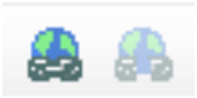 | The enlarged buttons shown here are for the Link and Unlink (here grayed out) functions.
Start by opening a page or other content in the editing mode.
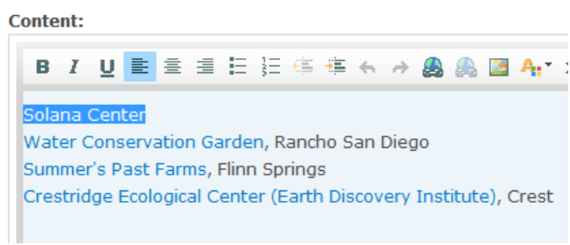 | Type in the text that will be the in-line link, and then select it with your cursor.  Now click on the link button in the editor button bar.
On-site or off-site links:
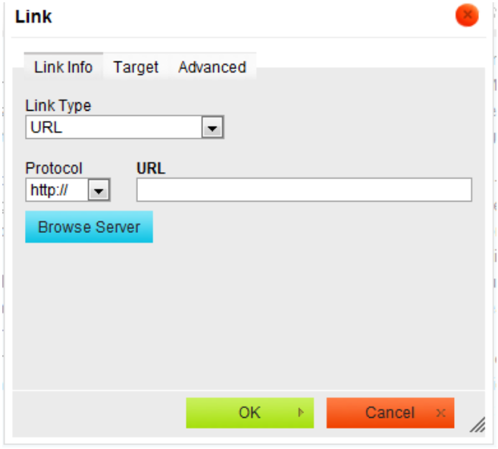 | This dialog box will open and you can now past in the URL for the target.  If you are making an on-site link, change the drop-down Protocol selection to “other”. For off-site links, leave it as http://  For an uploaded file, click on the Browse Server button and them go to the next page to continue.  Note: By clicking the Target tab at the top of the box, you can make the new page open in a separate browser window. (usually good for off-site links, so that your visitors don’t loose their place on your site) Select New Window (_blank) in the drop down list.  Click OK to finish.

Wysiwyg Editor – Link insertion and editing
Uploaded file link:
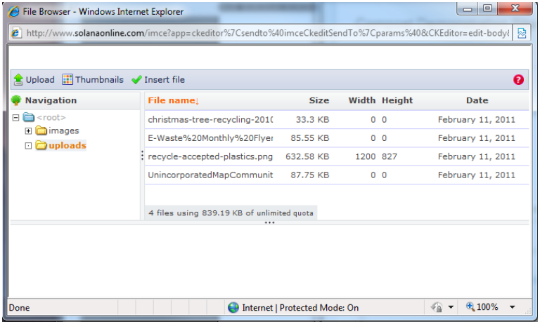 | Proceed as before to enter your link text and click on the link button and then on the Browse Server link.  Make sure you are in the uploads file folder and click on the green Upload link in the upper left corner.
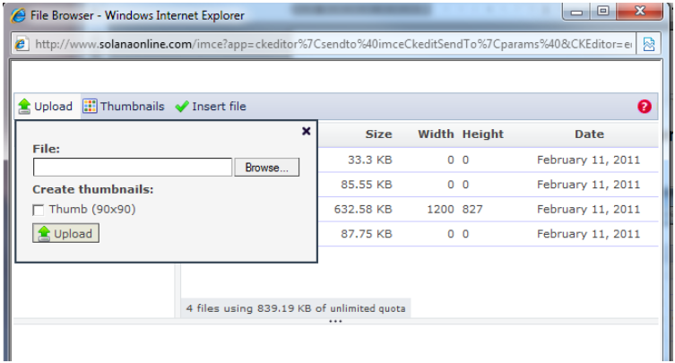 | An additional popup will open, now click the Browse button to browse your local computer and upload the file you want to link to.  After uploading, the new file, it’s name will appear in the file list, and you can select it by double clicking on it’s file name.

Un-Linking:
To use the unlink button, just select the link text and click the button to remove the unwanted link.

